Andrew Dunne

National College of Ireland  Mayor Square, IFSC

Business Entrepreneurship (Money Cloud LTD)

**Money Cloud LTD,**

**Business Plan**

**CONTENTS :**

**SECTION 1 EXECUTIVE SUMMARY.**

**SECTION 2 INTRODUCTION.**

**SECTION 3 MARKET.**

**Overview**

**Trend**

**Size and potential**

**Competition**

**Customers**

**Structure**

**S.W.O.T. Analysis**

**SECTION 4 MARKET STRATEGY.**

**Objectives**

**Product**

**Price**

**Place**

**Promotion**

**SECTION 5 ORGANISATION / MANAGEMENT.**

**Management Overview**

**Staff Requirement**

**SECTION 6 PRODUCTION AND OPERATIONS.**

**Premises**

**Plant and Equipment**

**Operations Overview**

**SECTION 7 COSTINGS & FINANCE**

**Financial Assumptions**

**Sensitivity Analysis**

***Section 1***

***Executive Summary of Money Cloud Ltd***

The overall aim of our idea is to eliminate the constant stress of always worrying about where your credit/debit card is. Also, as well as that, if the unfortunate case arose where you lost your card that you don’t have to worry about cancelling our card and applying for another one.

With Money Cloud, we offer a service that makes your money at lot easier to organise and ensure you budget it appropriately rather than

Company Name : Money Cloud Ltd

Address : Money Cloud Ltd,

IFSC

Mayor Street

Co. Dublin

Telephone : 01- 560 8400

Fax : 01- 560 8440

Co. Registration No.: 1800 945 ***

V.A.T. No.: IE 8495834 X

Accountants : Ronan Mc Ghee

Baldoyle Road,

Dublin 2.

Bank: BOI,

St. Stephens Green

Bank Centre,

Money Cloud is a company recently launched by four computing students – A . Dunne, C. Gilhooly, D. Fraine and D. Mc Keown – to satisfy the broad market of people who suffer from poor money organisational skills and enlighten them on a path to a less stressful budget without any hassle.

The company’s objectives into the future are:

1. To acquire deals with PTSB, Ulster Bank, AIB and Bank of Ireland before the end of year two.
2. To achieve a 25% market share by the end of year one.
3. To achieve a profitability of 30% after the end of year one.
4. Medium Term - to buy its own premises in the Dublin area.

This Business Plan is produced with a view to securing the necessary investment from :

Bank :

Term Loan € 60,000

Sponsers € 15,000

Investors € 15,000

Total € 90,000

**SECTION No. 2**

**INTRODUCTION**

**OVERVIEW.**

Money Cloud Ltd is a company recently launched by four computing students – A . Dunne, C. Gilhooly, D. Fraine and D. Mc Keown – to satisfy the broad market of people who suffer from poor money organisational skills and enlighten them on a path to a less stressful budget without any hassle.

We have identified a niche market for where we are going to launch our app. It is a very unique market which has potential to attract a majority of the countries attention. Only 32% of the population of Ireland take advantage of online banking. There are only a handful of countries who use the service less.

For such a low number of people using the service there is huge potential for this too grow especially considering how much is getting pumped into establishing these services.

All of the apps for Bank’s in Ireland are very similar and there are only small differences. For example, Bank of Ireland offer there feature where if the user is unaware of where the nearest ATM is. Then, the App will bring up a map of where the nearest ATM’s are.

The main similarity of most online banking apps allows you to transfer money to another account once the account is the same as the account sender. Our app will attempt to bring forward a solution where money can be transferred into a different account of a rival bank. This is all down to the security of our app and will take a lot of convincing before we can be trusted to transfer money.

The main focus of our group is to ensure security of the customer’s details and to provide an efficient service which transfers money in a quick fashion. As well as that, our app is going to help organise the financial problems a customer may have. The app will have a process where you enter your earnings for a week, month or even a year as well as your predicted expenditure i.e (rent, phone bill, gas and electricity etc). This is what makes our idea **unique**.

Despite having several unique ideas which seperates our app from current online banking apps we still have to ensure consistent change to ensure our presence is felt in this small market. Some of these ideas are as follows;

Future Implementation of ideas;

1. To establish a market dominance within first 5 years of business.
2. Propose setting up an independent Banking system completely ran online
3. To research current loaning systems and begin establishing our own system
4. To become first online bank that has its own section that solves problems students may have in regards to finance and offer long term loans with fair interest rates.
5. Becoming a grant provider for young business set ups

**GRANT ASSISTANCE.**

For Money Cloud LTD to become a powerhouse in today’s banking environment we need to seek financial assistance from the county enterprise board in the form of long term grants. We seek to an amount of €20,000 for our group to get up and running. This will go to the likes of equipment (laptops, software protection etc).

Ongoing talks with the county enterprise talks appear to be very positive as they are willing to offer €15,000 which we can prove very beneficial to the companies’ start up.

**Section No. 3**

**MARKETING**

The Market

Money Cloud LTD will seek to make a mark on the niche market of online banking which is not completely utilised in today’s banking environment.

**Overview**

The market is a very small one that we hope to make our unique mark on with simplicity and providing unique solutions.

The current market for online banking in Ireland is only controlled by 32% of the country. Considering 50% of the country are currently using smart phones and the number is consistently growing there is huge opportunity for our app to grow and develop.

The big two will hold on to 80 per cent of the market. As things pick up in the economy in the years ahead, we may see smaller specialist operators come in. Other factors will nibble away at what they do, such as growth in the payments business by technology giants, or the likes of Tesco offering more financial services. Others will probably come in and compete for deposits.

AIB and BoI will probably see their collective market share fluctuate between 75 per cent and 85 per cent of the domestic banking market. The mythological Irish banking third force remains as elusive as ever. PTSB is struggling, however this is not necessarily a bad thing it just means that it will be a lot easier for us to influence them to invest in our app due to their lack in market presence. KBC is active but small.

**Source (www.independent.ie)

The market for banking in Ireland is shown in the table hereunder:

*(Tables in billions/Assets)*

Market Share

Bank of Ireland 77.4

Allied Irish Bank 74.6

PTSB 54.5

€206.5 Billion

**Source: (www.centralbank.ie)

**Market Trend**

The Irish Economy is one of the fastest growing economies in Ireland. The trend is only going upwards and can be seen from last year’s quarter because it showed us that the purchasing of cars (by loans) was the highest since the country entered Recession.

The market is on the way up and there is no sign of it slowing down, this is the ideal time for our app to enter the market. There is more and more pressure for banks to let out loans for houses, businesses etc. Businesses cannot function without seeking loans to further build their business.

If our app can make a small mark in the market it will gradually grow and become a permanent mark and will be a force that will not be taken lightly by competitors.

**Size and potential**

The more research that is done the more indications there is for a positive outcome of our app. The fact the banking market is constantly fluctuating means that there is always change in the market. Due to our app having very unique features that other banks don’t have it could be the ideal time for us to set the standard of how online banking should be done.

**Competition**

Despite all of the banks having online banking they are only competitors. Nobody is attempting to develop any app like ours at the current moment. There is no obvious threats other than the banks themselves however this is no reason for us to lack in our development and we should still retain a good reputation for the company and keep the standard high.

The niche market which Money Cloud Ltd have chosen is for online banking, money organisation and student supplements. This niche has potential to be worth around €10-15 million in the Dublin and greater Ireland area. At this current time we are unable to identify any real threats other than the current app designers for the banks now but our idea has so many extra features that I can’t see them having any threat to our idea.

**Customers**

The potential for this market to grow is huge. The fact only 33% of the country use smart phones and will grow up to 50% and higher over the next 6 months according to recent surveys.

List of Target Customers:

Bank of Ireland

KBC

PTSB

AIB

Ulster Bank

Bank of Scotland

Credit Union?

S.W.O.T. Analysis

**STRENGTHS**

Recent history with online banking has nothing but negative comments mainly due to poor development and lack of features. Our app has a consistent and relevant structure suited to what customers need and want.

As well as that with the right promotion and portrayal of what our app is about we should penetrate the market with ease and banks will be more inclined to take on our idea as it will outline the weaknesses of their apps and make our idea look more attractive and trustworthy by using the weaknesses of their app to strengthen ours.

**WEAKNESSES**

With the lack of financial support marketing our idea will not be as easy as it could be however this all depends on the support we get. It will be hard at the start considering that all banks already have their apps up and running where as we are attempting to penetrate a market already completely.

**OPPORTUNITIES**

There is an unlimited amount of opportunities for our app to blossom in today’s online banking market. Despite our idea having huge potential to grow in the future depending on how on how act on the market the short term for our idea is not what we are focusing on.

Within a year of setting up we hope to sign on 5 of the major banks in Ireland, with the sign on fees and wage for setting up the app for them we aim to be up and running very quickly with all things going our way.

**THREATS**

The biggest threat for our app is if app developers attempt to challenge our idea so we need to ensure we are constantly adding new features to our app that actually matter. It will be very hard to decipher between what matters to customers and what we think matters to customers so we have to be very careful.

**MARKET STRATEGY**

In order to achieve a successful impact on the market and achieve our future projections we have set out a strategy that we need to stick by;

**Objectives**

• To acquire deals with PTSB, Ulster Bank, AIB and Bank of Ireland before the end of year two.

• To achieve a 25% market share by the end of year one.

• To achieve a profitability of 30% after the end of year one.

• Medium Term - to buy its own premises in the Dublin area.

**Product**

Money Cloud Ltd is a company recently launched by four computing students – A . Dunne, C. Gilhooly, D. Fraine and D. Mc Keown – to satisfy the broad market of people who suffer from poor money organisational skills and enlighten them on a path to a less stressful budget without any hassle. We aim to bring an efficient running of online banking app like never seen before. The service will have a constant call centre for those who have any problems as we want to ensure customers of having confidence when use our app.

**Price**

We aim to have a sign on fee and pay for developing the app at a set cost of €500,000 per bank. We feel this is a fair fee as we will be supplying them with a far more efficient and responsive service. This fee is fair as well have to cover our background staff which will be a part of the service. There will be room for bargaining depending on how big a job may be but this should be the standard price.

**Place.**

We have situated ourselves in the IFSC the heart of business in the Dublin area and feel there is no better place to be placed. We have a strong advantage over our competitors and we are also situated near a BOI so development will be easier due to location.

***Operations***

***Premises & Equipment***

Money Cloud will work and produce from an office building within the IFSC , Dublin 1 where all production for the app will go ahead.

This location is perfect as many of our target markets are located closely within the IFSC with AIB and Bank of Ireland within a stone’s throw from our office.

To begin with we are happy with renting the current premises but in the future we are considering purchasing the office. The overall appearance of the office will have to be renovated to match our criteria such as a new layout for staff members working in different fields of work such as our customer service/call centre which will have to be located away from our production area.

In regards to equipment we will have invest heavily in the best quality desktops for our production side of the business which will make the production speed of our app as quick as possible. Our customer service/call centre area will require several desktops and also landlines.

Considering we have choose not to outsource our production team will require the following equipment to produce the app;

* Office
* Desktop
* Landline
* Broadband

We have decided to use the Apple Developer Program which offers various software for the developing of the app. This program is beneficial for our company as Apple offers up to date and reliable software and also handles worldwide payment processing so if we are successful nationwide firstly which is our main goal this will give us a platform to build on to aim to bring our app globally and gives us a new target market.

***Production***

In regards to production the process is quite straight forward the developers will develop the app for which ever customer it may be, let’s use AIB for example .Our developers will develop the app for AIB and submit it to the app store. Pending approval from the app store the app will then be launched and available on the app store to AIB bankers. All they will be required to do is download it from the app store using their iTunes account. Then to gain access to the app they will need their bank registration number and also a pin code in which they have already made themselves when they joined the bank. These details will be all that is required to use our Money Cloud App. This makes the app very easy and straightforward for users without causing them any un-wanted hassle while using the app. The interface of the app will be designed to be as simple and beneficial for our users.

***Distribution Channel***

The distribution channel for our app would be the Apple Appstore but our main distribution channel would be banks. We would be targeting banks to purchase our app and then the Appstore would take over on the distribution front with members of the certain bank downloading the app.

***Quality Control***

In regards to our own quality control we as a company want to ensure the best of quality for our app as this will be vital to how successful the app is in the launching and future and for future investors and our target market. To ensure all of this we will have a quality control team and they will be responsible for testing the responsiveness and quality of the app.

We have high standards to reach if we are going to be successful in submitting our app to the Apple store. We must ensure we have a well-designed and easy to use interface for our app.

Other banking apps have very little features and our very basic we are aiming to create a well- designed easy to use app with a lot of useful features for its users.

***Management/Organisation***

***Organisation***

Money Cloud is new start-up business with all shares owned equally by its four founders.

*Management*

Considering the four founders previous backgrounds in various fields ranging from IT, computer programming, business and marketing just to name a few all four take up full time positions without taking wages within the organisation. We will have four full time workers split between two fields our Quality Control team and Customer Service/Call centre.

***Dylan McKeown***

**Marketing & Sales**

Degree in Marketing Innovation & Technology

6 year’s work experience in Diageo.

***Andrew Dunne***

**IT Director**

Degree Management of Technology in Business

5 year’s experience in KPMG.

***David Fraine***

**Finance**

Degree in Accounting & Finance

8 year’s experience in AXA Insurance.

***Conor Gilhooly***

**Marketing & Sales**

Degree in Marketing

5 year’s experience in Google.

(Full Curricula Vitae are included in the Appendices for the Directors )

***Staff Requirements***

Directors 4

Call Centre 3

Quality Control 1

Total 8

We will put an add online to recruit for our call centre team. Our add will indicate what is required to take up a position in our team. We will be looking for people with previous experience in call centres for ideally 2+ years.

We are going to recruit our quality control by putting an add online and we will clearly indicate we are looking for a computer literate with previous experience in app development.

***Finance***

***Financial Projections:***

The whole outline of our financial costing’s and operations for the first year of the business is contained in the Appendices. We feel these costing’s are reasonable considering our start-up idea.

***Sales:***

The projected sales for the year are based on Banks wanting to invest in our idea. We are looking for a sign on fee of €500,000 per bank as a set rate for us to set up the app and get it up and running for the bank. We are hoping to target 5 Banks for the year at 500,000 which would leave our projected sales for the first year at 2,500,000.

***Expenses:***

The full schedule of our expenses for Money Cloud Ltd is contained in the Appended part of our Business Plan. These expenses are based on current prices and are realistic considering we are only at the start-up of our business idea.

***Detailed job Costing overview:***

Full analysis of the Labour Rate build-up are given in the Appendices and the Unit Sales / average job costing make up is as follows:

Unit Pricing per month:

**Labour :** €7,750

**Materials**: €4,000

**Total Direct costs:** €15,000

**Market Selling Price**: €500,000

**Contribution:** €25,000

***Sources of funds:***

**Sponsorship:** €15,000

**Bank term loan:** €60,000

**Investors:** €15,000

Cash Flow( 12 Months)

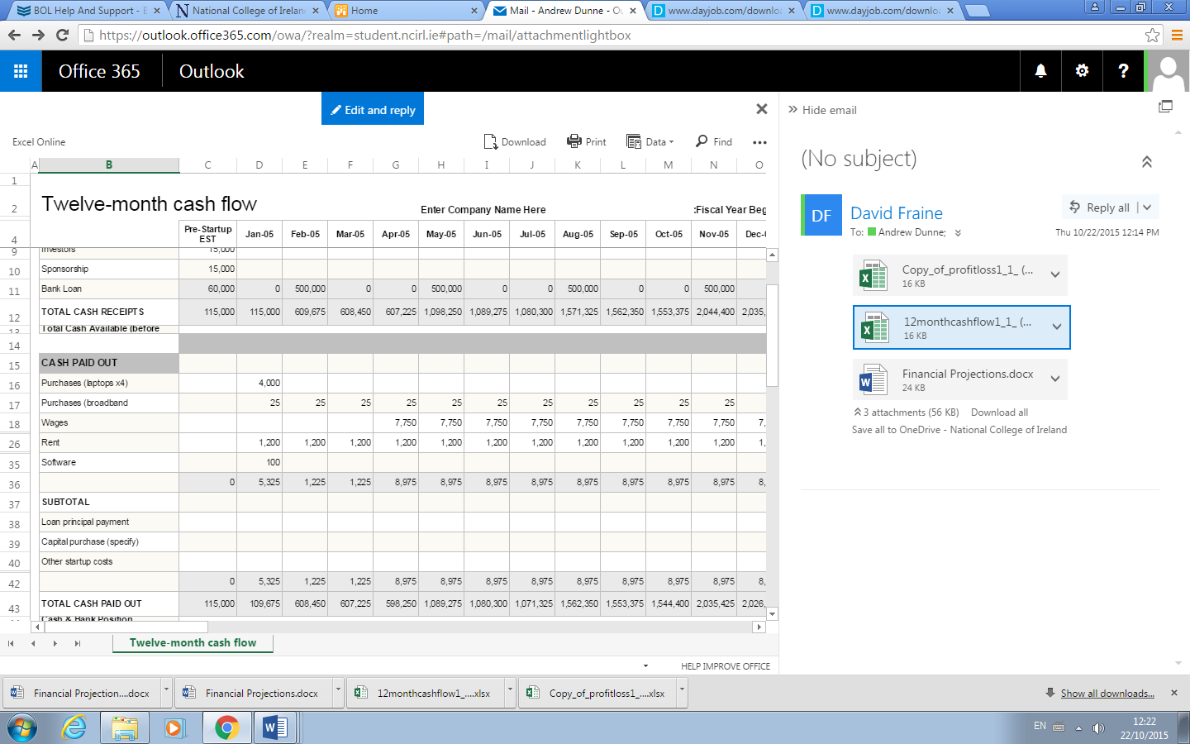

(Profit and Loss Account)

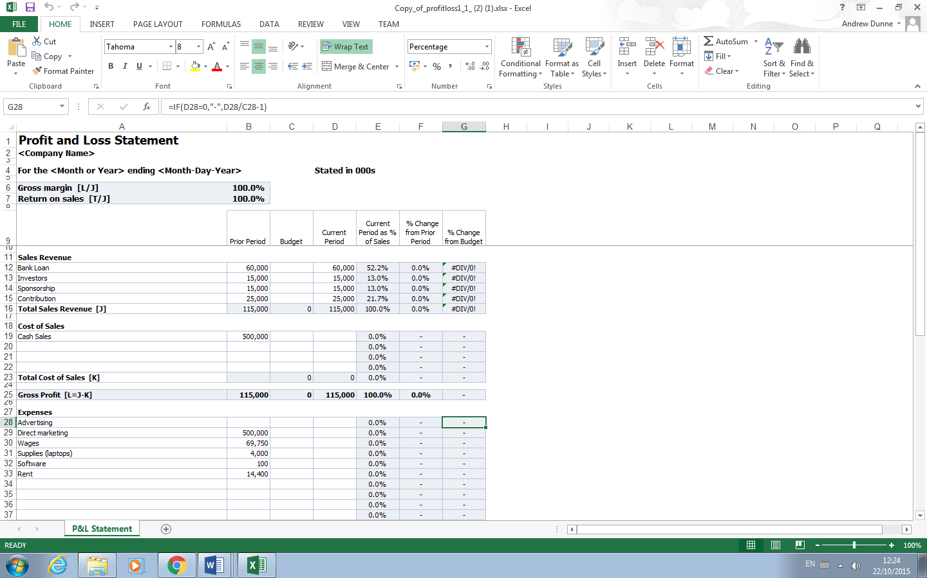

(Continued)

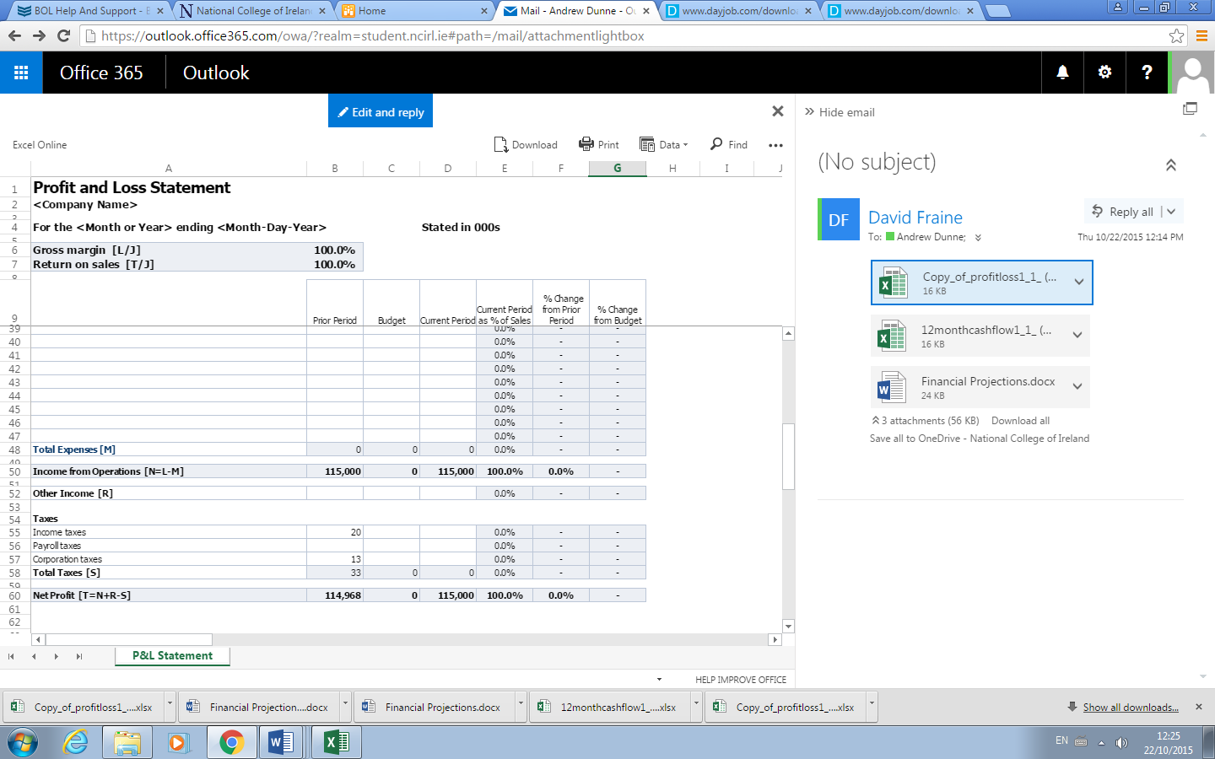

Appendices

**Andrew Dunne**

3 ParkView,

Swords

Co. Dublin

Ph: 0857840189

email: [dunner_andrew1@hotmail.com](mailto:dunner_andrew1@hotmail.com)

D.O.B. 12 September 1995

**Key Skills and Abilities**

* Strong work ethic – proven hard worker
* Punctuality – reliable and responsible
* Good communication skills - great listener and communicator
* Ability to work with a team – confident team leader
* College course Rep

**Education and Training**

**2013-2014 Colaiste Dhulaigh CFE, Barryscourt Rd., Coolock, Dublin 17**

**Business & Tourism**

**Modules**

Communications

Word processing

Customer service

Work experience

Amadeus/ Galileo

Marketing

Tourism Policy and practice

Information and administration

Appreciation of Irish Culture

Heritage

**2014-Ongoing National College of Ireland, Management of Technology and Business**

**Modules**

Marketing Business Entrepreneurship

Business Programming

HTML and Web Design Data basing

Software Engineering Accounting

Multimedia Management Information Systems

Human Resource Management

Quantitative Methods

|  |  |  |
| --- | --- | --- |
|  |  |  |

(David Fraine) Curriculum Vitae

I am a hardworking, reliable, organised individual with exceptional communication and interpersonal skills. I am highly motivated, committed and enjoy challenging myself. I work well individually and as part of a team.

**Education**

September 2009 – June 2015 Castleknock Community College

September 2015 – May 2019 National College of Ireland

**Subjects Studied**

|  |  |  |
| --- | --- | --- |
| Marketing | Financial Accounting | Managerial Foundations |
| Business Entrepreneurship | Data base | HTML |
| Human Resource Management | Introduction to Programming | PPD |

**Skills Developed**

I am still currently undergoing my college modules in Management of Technology in Business, and completed a two year accounting course in D.I.T. But having studied most of the subjects above I have a strong knowledge of Business, Technology and Personal Development. I have worked in the retail industry which has given me copious amounts of experience in dealing with customer relations and being able to implement my knowledge of Business in the workplace. This course has also helped me be creative and developing my skills personally into further depth.

**Mr Dylan Mc Keown**

26 Island View , Galway

**Email: Dylan_mckeown@hotmail.com**

**Mobile: 085 145 6421**

**Personal Profile**

I consider myself to be an honest, hardworking individual who can work well under pressure or as part of a team. I am looking for a position where I can use my skills and abilities and develop new ones.

**Employment History**

Company : **Diageo**

Position: **Regional Marketing Manager**

Start Date: **1/1/2009**

End Date: **1/1/2015**

Company: **BMW**

Position: **Internship**

Start Date: **1/1/2008**

End Date**: 31/12/2008**

**Education & Training**

**DCU** 2002-2006

Qualification - **BSc in Marketing, Innovation and Technology**

**DIT** 2006-2007

Qualification - **MSc Marketing**

**References**

If any references are required please contact me and I will inform you of all valid and up to date contact information for my referees.

References

Independent.ie,. 'Richard Curran: Banks' Demise Is Double Trouble - Independent.Ie'. N.p., 2013. Web. 20 Oct. 2015.

IRELAND, C.

Central Bank of Ireland - Irish Locational Banking Statistics

In-text: (Ireland)

Bibliography: Ireland, Central. 'Central Bank Of Ireland - Irish Locational Banking Statistics'. Centralbank.ie. N.p., 2015. Web. 20 Oct. 2015.